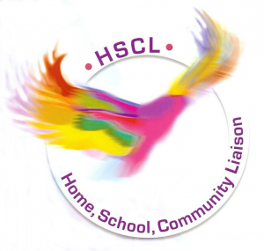 

|  |  |  |  |
| --- | --- | --- | --- |
| Time and Date | Class | Start Date | Venue |
| Monday  (10:00-12:00) | Health and Beauty | End of September | Online |
| Monday  (10:30- 12:30) | Art | End of September | Online |
| Wednesday  (9:00 – 11:00) | Cookery | End of September | Online |
| Thursday  (10:00 – 11:00) | Fitness | End of September | Online |
| Friday  (10:00 – 12:00) | Art and Crafts | End of September | Online |
| Contact the HSCL Co-Ordinator for more information  Tommy Liddy – 087 929 9782 Linda Donohue – 087 668 2151  Noreen Kinane - 085 157 3302 Elaine Considine – 087 210 1903 | | | |
|  | | | |

Parent Classes Sexton Schools